Chimp Andy’s Resources



Chimp Andy is expecting you to create a spreadsheet and calculate how much money he has invested in his ‘resources’

STAGE 2

1. Don’t forget, Chimp Andy wants you to use formulas for your calculations. In the ‘total value’ column write a formula to calculate the total value of each item he owns.
HINT: Remember, formulas always start with an =
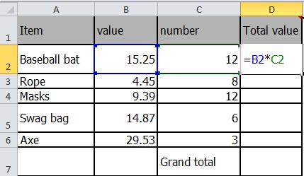

You must do this for all the items in the Item column

2. Write a SUM formula to work out the ‘Grand total’. Remember, this formula must be correct if you don’t want to annoy Chimp Andy.

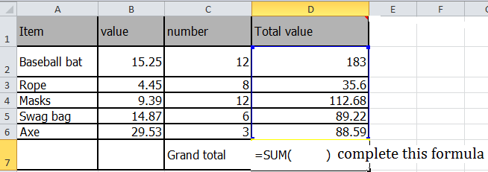

3. Format all of the items in the ‘value’ and ‘total value’ columns as currency to two decimal places

